TRAVEL ADVICE
THE CONFERENCE VENUE
The 1st EUFLYNET Meeting & Training School will take place on Wednesday 28 February – Friday 1 March 2024, in Jastarnia, on the Hel Peninsula, ca. 70 km NE of the city of Gdańsk in Poland.
The conference venue is:
The Dom Zdrojowy Resort & SPA Hotel
https://www.hoteldomzdrojowy.pl/en/
Address: Kościuszki 2a, 84-140 Jastarnia, Poland
Tel. (landline): + 48 58 67 99 100, Tel. (cell): +48 607 269 267
Email: rezerwacje@hoteldomzdrojowy.pl
The hotel reception is open 24/7.
The location is: https://maps.app.goo.gl/YupSPeDt8uVyn81o6,
HOW TO GET TO JASTARNIA?
- From Gdańsk Lech Walesa Airport (https://www.airport.gdansk.pl/) to Jastarnia:
by two local trains, with a change at the station Gdynia Główna:
Train 1: from station: Gdańsk Port Lotniczy to station: Gdynia Główna,
Train 2: from station: Gdynia Główna to station: Jastarnia

- From the main railway/bus station Gdańsk Główny:
by two local trains, with a change at the station Gdynia Główna:
Train 1: from station: Gdańsk Główny to station: Gdynia Główna,
Train 2: from station: Gdynia Główna to station: Jastarnia.

- From the main railway/bus station Gdynia Główna:
by one local train from station: Gdynia Główna to station: Jastarnia
Train timetables and tickets are available at: https://rozklad-pkp.pl/en/ The timetable might slightly change at times, so please check it just before you travel. You can buy train tickets online, but no earlier than a month before the travel. You can also buy the tickets locally at the ticket machine at the platform or in the train from the conductor.
- You can also drive by car. Please, note that the hotel will charge you an additional fee (80 PLN/day) for a parking place by the hotel.
The hotel Dom Zdrojowy is close to the railway station in Jastarnia (ca. 9 min walk) :
https://www.google.com/maps/dir/Jastarnia,+Jastarnia/Dom+Zdrojowy+Jastarnia,+Ko%C5%9Bciuszki+2a,+84-140+Jastarnia/@54.7002595,18.6775025,17z/data=!3m1!4b1!4m13!4m12!1m5!1m1!1s0x46fdaa5b143cc991:0xc5ea8fc9ef1a21a1!2m2!1d18.677516!2d54.7011855!1m5!1m1!1s0x46fdaa5ce6c1f567:0x7708b2f85b26f137!2m2!1d18.682875!2d54.6998944?entry=ttu
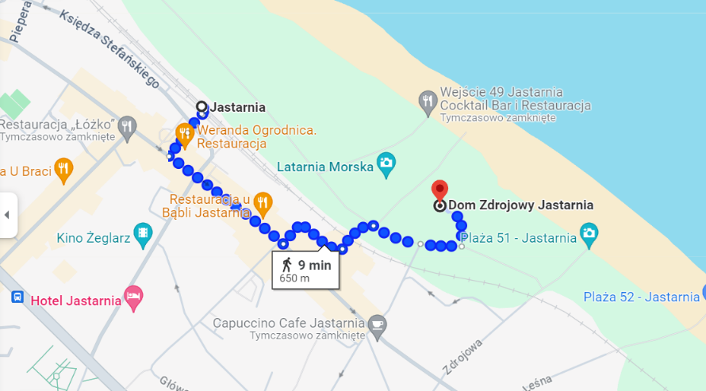

MONEY ADVICE
Please, note that Poland is not in the Euro zone, the local currency is Polish Złoty (PLN). Most places, including shops, trains, taxis etc., and at the conference venue, you can pay by Visa or MasterCard. You will also be able to withdraw cash in Polish Złoty at any ATM. Exchange offices are available at the airport, at the largest train stations like Gdynia Główna and Gdańsk Główny, and in largest shopping centres, but not in small places like Jastarnia.

